Scope:
Applies to toys for children, toys being any product or material designed or intended for use in play by children of less than 14 years.

Registration & Authorization Requirements
Registration | Law No. 28376  D.S.No.008-2007 SA  Link:  https://www.gob.pe/institucion/minsa/normas-legales/249239-008-2007-sa | Any natural or legal person that is going to manufacture, import, sell, distribute and / or store toys must apply for registration to the Regional Directorate of Department of health or health of Lima, accordingly its tax domicile. The register shall be a defined period of five (5) years renewable.  Any modification or change in the data under which was awarded the National Registry, must be communicated in writing to the health authority that granted, up to seven (7) days after being made to that effect, with the support of the information modification.  Required for National Registry:  - Application form -Sworn statement addressed to the Director of the competent health authority,  - Identity information:  Natural person: full name, RUC, address.  Legal person: company name, legal representative, RUC, legal address.  - Power of attorney: If application is filed through a representative.  - Activity description: Indicate which activities will be carried out (manufacture / import / distribute / market / store) and their locations.  - Operating license: Copy of municipal license for each establishment (own or leased).  Registration application form template please see Annex 1&2.
Authorization | Law No. 28376  D.S.No.008-2007 SA  Link:  https://www.gob.pe/institucion/minsa/normas-legales/249239-008-2007-sa | Manufacturing or importing toys, it is necessary to obtain a "health / Import authorization", issued by the Regional Health Directorate or the Lima Health Authority, valid for 5 years.  The materials required for authorization include:  1. Application: Health Authorization with manufacturer’s name, address, RUC, legal representative. Import Authorization with importer’s name, address, RUC  2. A copy of the registration certificate  3. Original or copy of the test report (issued by an INDECOPI accredited laboratory or an internationally accredited laboratory)  4. Draft product label (registration number and authorization number must be displayed)  5. Product description (model, brand, tariff code, etc.)  6. Proof of payment
Safety Requirements
Safety of toys (Mechanical and physical) | Law No. 28376  D.S.No.008-2007 SA  Link:  https://www.gob.pe/institucion/minsa/normas-legales/249239-008-2007-sa | Shall comply with D.S.No.008-2007 requirements. Acceptable equivalent standards: EN 71-1 or ASTM F963.  Test report from an accredited Lab, Lab accredited by entities international Laboratory accredited in the country.
Safety of toys (Flammability) | Law No. 28376  D.S.No.008-2007 SA  Link:  https://www.gob.pe/institucion/minsa/normas-legales/249239-008-2007-sa | Shall comply with D.S.No.008-2007 requirements. Acceptable equivalent standards: EN 71-2 or ASTM F963.  Test report from an accredited Lab, Lab accredited by entities international Laboratory accredited in the country.
* Safety of toys (Migration of certain elements) | Law No. 28376  D.S.No.008-2007 SA  Link:  https://www.gob.pe/institucion/minsa/normas-legales/249239-008-2007-sa | Shall comply with D.S.No.008-2007 requirements. Acceptable equivalent standards: EN 71-3 or ASTM F963.  Test report from an accredited Lab, laboratories accredited by entities international Laboratory accredited in the country.
* Safety of toys (Phthalate content) | Law No. 28376  D.S.No.008-2007 SA  Link:  https://www.gob.pe/institucion/minsa/normas-legales/249239-008-2007-sa | For Pacifier and toys used in mouth, shall not contain concentrations of more than：  3% Bis(2-ethylhexyl) phthalate (DEHP),  1% Butyl benzyl phthalate (BBP),  43% Diiso nonyl phthalate (DINP),  Prohibited ：Dibutyl phthalate (DBP)，  Diisodecyl Phthalate (DIDP)，  Di-n-octyl Phthalate (DNOP).  For soften plastics, shall not contain concentrations of more than：  1% Butyl benzyl phthalate (BBP),  43% Diiso nonyl phthalate (DINP),  Prohibited ：Dibutyl phthalate (DBP)，  Diisodecyl Phthalate (DIDP)，  Di-n-octyl Phthalate (DNOP).  Test report from an accredited Lab, laboratories accredited by entities international Laboratory accredited in the country.
*Safety of toys (Cadmium Content) | Law No. 28376  D.S.No.008-2007 SA  Link:  https://www.gob.pe/institucion/minsa/normas-legales/249239-008-2007-sa | The maximum permissible limit of cadmium in products made of PVC, polyurethanes, low density polyethylene, cellulose acetate, cellulose acetobutilo and epoxy resins, is 0,01% by weight of the plastic material.
*Safety of toys (Migration of certain elements) | Law No. 28376  D.S.No.008-2007 SA  Link:  https://www.gob.pe/institucion/minsa/normas-legales/249239-008-2007-sa | The maximum permissible limit of below heavy metal in any toy as below:  For toys other than modeling clay  Soluble Arsenic (As): 25 ppm  Soluble Antimony (Sb): 60 ppm  Soluble Barium (Ba): 1000 ppm  Soluble Cadmium (Cd): 75ppm  Soluble Chromium (Cr): 60 ppm  Soluble Lead (Pb): 90 ppm  Soluble Mercury (Hg): 60 ppm  Soluble Selenium (Se): 500 ppm  For modeling clay  Soluble Arsenic (As): 25 ppm  Soluble Antimony (Sb): 60 ppm  Soluble Barium (Ba): 250 ppm  Soluble Cadmium (Cd): 50 ppm  Soluble Chromium (Cr): 25 ppm  Soluble Lead (Pb): 90 ppm  Soluble Mercury (Hg): 25 ppm  Soluble Selenium (Se): 500 ppm
*Safety of toys (Nickel Release) | Law No. 28376  D.S.No.008-2007 SA  Link:  https://www.gob.pe/institucion/minsa/normas-legales/249239-008-2007-sa | Toys that come into direct and prolonged contact with the skin, the parties of nickel release may not exceed 0.5 μg/cm2/week (no body-piercing limit specified)
*Safety of toys (Solvent) | Law No. 28376  D.S.No.008-2007 SA  Link:  https://www.gob.pe/institucion/minsa/normas-legales/249239-008-2007-sa | The solvents used in the manufacture of toys should be removed from the product finished so that the residual concentration of these can affect the health of children.  In any case, these solvents in the liquid state are prohibited in toys.
*Safety of toys (Benzene Content) | Law No. 28376  D.S.No.008-2007 SA  Link:  https://www.gob.pe/institucion/minsa/normas-legales/249239-008-2007-sa | The concentration of Benzene should not exceed 5 mg / kg weight of the toy or part of a toy.
*Safety of toys (Toluene Content) | Law No. 28376  D.S.No.008-2007 SA  Link:  https://www.gob.pe/institucion/minsa/normas-legales/249239-008-2007-sa | As a residual impurity is only permitted in toys and stationery in a concentration does not exceed 170 ppm (170 mg per kg of toluene toy).
*Safety of toys (Ammonium) | Law No. 28376  D.S.No.008-2007 SA  Link:  https://www.gob.pe/institucion/minsa/normas-legales/249239-008-2007-sa | Not accept articles of joke games, or objects to be used as such (e.g. Powders Sneezing, rubber caps, etc.) in amounts that exceed 1.5 ml(each):  (a)ammonium sulphide (CAS No. 12135 - 76 - 1) (b)Ammonium hydrosulphide 12124 - (CAS No.  99 - 1)  (c)Ammonium polysulphide (CAS No. 12259 - 92 - 6)
*Safety of toys (Bromoacetate) | Law No. 28376  D.S.No.008-2007 SA  Link:  https://www.gob.pe/institucion/minsa/normas-legales/249239-008-2007-sa | Not accept articles of joke games, or objects to be used as such (e.g. Powders Sneezing, rubber caps, etc.) in amounts that exceed 1.5 ml each Bromoacetate:  (a) methyl (CAS No. 96 - 32 - 2)  (b) acetate (CAS No. 105 - 36 - 2)  (c) propyl (CAS No. 35223 - 80 - 4)  (d) butyl (multiple CAS number)
*Safety of toys (chemical substances) | Law No. 28376  D.S.No.008-2007 SA  Link:  https://www.gob.pe/institucion/minsa/normas-legales/249239-008-2007-sa | Substances and preparations which contain one or more of the following substances:  (a) creosote (CAS No. 8001 - 58 - 9)  (b) creosote oil (CAS No. 61789 - 28 - 4)  (c) Distillates (coal tar), naphthalene oils (CAS No. 84650 - 04 - 4)  (d) creosote oil, naphthalene fraction (CAS No 90640-84-9)  (e) Distillates (coal tar), superior (CAS No. 65996 - 91 - 0)  (f) anthracene oil (CAS No. 90640 - 80 - 5)  (g) of crude coal tar acids, (CAS No. 65996 - 85 - 2)  Wood creosote, H) (CAS No. 8021 - 39 - 4)  (i) Extract residues (coal), coal tar alkaline low temperature (CAS No. 122384 - 78 - 5).  May not be used in toys and recreational facilities, parks, gardens and garden furniture.
Electric toy requirement
*Safety of toys ( Electric toy ) | Law No. 28376  D.S.No.008-2007 SA  Link:  https://www.gob.pe/institucion/minsa/normas-legales/249239-008-2007-sa | Shall comply with EN IEC 62115 requirements.  Test report from an accredited Lab, lab accredited by entities international Laboratory accredited in the country.
Labelling Requirements
General Labeling | Law No. 28376  D.S.No.008-2007 SA  Link:  https://www.gob.pe/institucion/minsa/normas-legales/249239-008-2007-sa | Spanish Language. The content of the label must be affixed in a visible and legible on the product packaging or packaging, depending on the nature of the product.
Name, address of the importer, RUC or manufacturer | Law No. 28376  D.S.No.008-2007 SA  Link:  https://www.gob.pe/institucion/minsa/normas-legales/249239-008-2007-sa | Required:  (a) name or business name and address of the importer, RUC or manufacturer.  (b) country of manufacture of the product.  (c) the name or designation of the product  (d) Code of the product.  The information on the name or business name, name or description of the product, can be appropriate in source language.
Instructions of Use | Law No. 28376  D.S.No.008-2007 SA  Link:  https://www.gob.pe/institucion/minsa/normas-legales/249239-008-2007-sa | Information on use and installation, in case be required for its proper functioning.
List of materials used on the manufacturing  process | Law No. 28376  D.S.No.008-2007 SA  Link:  https://www.gob.pe/institucion/minsa/normas-legales/249239-008-2007-sa | The list can be put on the product itself or its packaging or in a sheet that is inside the packaging.
Authorization # of the local authority | Law No. 28376  D.S.No.008-2007 SA  Link:  https://www.gob.pe/institucion/minsa/normas-legales/249239-008-2007-sa | National registration number and number of manufacturer or authorized importer. The number as required by import requirements, must be provided by importer to be put on the label.
Age grading | Law No. 28376  D.S.No.008-2007 SA  Link:  https://www.gob.pe/institucion/minsa/normas-legales/249239-008-2007-sa | Minimum age must be clearly specified.
Warnings | Law No. 28376  D.S.No.008-2007 SA  Link:  https://www.gob.pe/institucion/minsa/normas-legales/249239-008-2007-sa | Warning must be in accordance to the age grading, the presence of small parts and use of the product.  (If needed in accordance with EN 71-1 or ASTM F963)
EPR (Extended producer responsibility)
Prohibition of certain plastic goods | Law No. 30884  Link：  https://www.gob.pe/institucion/minsa/normas-legales/249239-008-2007-sa | By 19 December 2019, it shall be prohibited to:  a)Manufacture, import, distribution, sale, and use Plastic bags (<900 cm² or <50 microns)；  b)polymer-based sorbents such as drinking straws，except medical use；  c)non-biodegradable polymer-based bags, including additives that catalyze the fragmentation of such materials into micro fragments or microplastic.  By 19 December 2021, it shall be prohibited to:  a) polymer-based plastic bags, that are not reusable and those whose degradation generate contamination by microplastic or dangerous substances.  b) polymer-based plates, glasses and other utensils and crockery for food and beverages for human consumption, which are not recyclable and those whose degradation generate contamination by microplastic or dangerous substances.  c) containers or packaging and expanded polystyrene cups (technopop) for food and beverages for human consumption.
Biodegradable Plastics | Law No. 30884  Link：  https://www.gob.pe/institucion/minsa/normas-legales/249239-008-2007-sa | All biodegradable plastics must be certified by an accredited lab. Certified biodegradable products are exempt from plastic bag tax.

Annex 1: Registration Applicable form template of Natural person
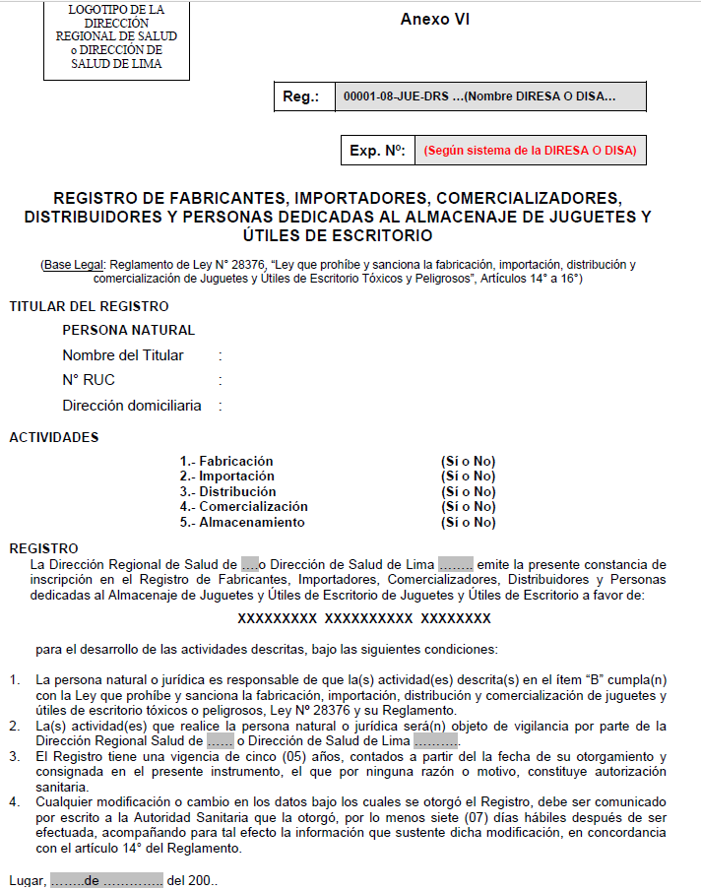

Annex 2: Registration Applicable form template of Legal person
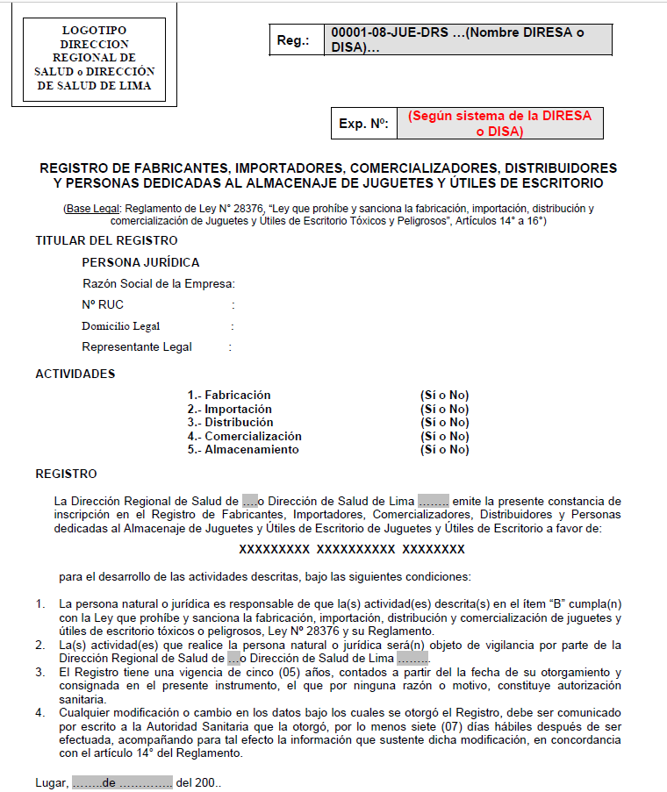

PRICING AND ADDITIONAL NOTE :
-- Attributes being marked with “*” are not covered by basic package price, additional charge will be required if they are applicable.

** It is the suggested number of samples required for complete testing only. Sample size/raw materials and number of working days may vary depending on the actual sample’s size and the number of tests required for testing. Please consult your nearest laboratory for details. In order to keep sample size the minimum, SGS will inform the supplier the exact number of samples after sample review.

 | ** No of Sample Required:
No. Of Samples Required For Complete Testing: |  | Generally, 6pcs, if sample or component is insufficient to schedule testing, it may be required to provide additional samples to schedule testing:  - Chemical test (if any) should be more than 20g.  - substances and preparations (if any) should be more than 30g.
No. Of Working Days For Complete Testing: |  | 7 – 9

Review History
Review No | Review Date | Reviewed by | Changes
0 |  |  | Initial Release

The Company’s consulting services, including any review of product safety regulations and industry standards listed in product protocols (“Protocols”) are based upon information provided by client, Company’s know-how and on publicly available sources at the time the services were supplied. Client is responsible for providing any and all information about its product design, manufacture and other accurate information that may be required to complete the protocols. Client is responsible for his decision to make whatever use of the information contained in the Protocols and accepts all risks for any loss or damage of any kind that may occur hereof. In addition, client shall be sole responsible for all liabilities for injuries caused by defects in the design, manufacturing or labelling of their products. Protocols must be used as guidance only, as similar products may have different detailed test requirements depending on specific functions. Company disclaims any and all liability for the accuracy of any such publicly available information or any legal interpretation of such information. SGS provides its services in a consulting capacity only and offers no legal opinion(s) herein. The opinions provided by the Company are not a substitute for professional legal advice and client should seek legal review to ensure compliance with any applicable laws and regulations.
The Company’s consulting services are governed by and subject to the General Conditions of Service at www.sgs.com/terms _and_conditions.htm. ©2023 SGS SA. All rights reserved.

